Symbolic Computation Using Big Data Deliverables

Ted Nguasong

Bowie State University

CTEC 298-101

Dr. Bemley

21 OCT 2021

**Introduction** **2**

CTEC 298 introduced different methods of proofing data. Applications like Jupyter Notebook, and Github provided a way to store and examine the data in python. Using aditionals tools more insights into the data was able to be explored.

Unemployment is defined as people who are not employed, available to work, actively looking for work within a four-week period, and/or laid off temporarily and waiting to go back to work by the U.S. Bureau Labor of Statistics (2021). The health of the nation’s economy is often equal to the employment rate in the nation. To compute unemployment, the number of unemployed people is divided by the number of people in the labor force thus creating the employment rate. Dividing the number of unemployed people by the number of people in the labor force, the nation’s unemployment rate before COVID-19 was 7.80% as of January 2019 according to Organization for Economic Co-operation and Development (OECD, 2021). For this project, we plan to analyze the impacts that race, age, sex, educational attainment, and location may have on unemployment in the United States.

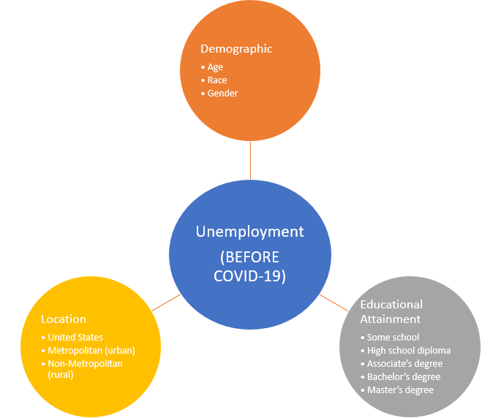

Our Main Objective was **t**o Determine whether a person's demographics, educational Attainment  and location impact  their unemployment Status (Pre-COVID) and our Main Research Questionwas to find out can we determine a person’s race, age, sex, education attainment, or location factors contribute to their unemployment? Our purpose was to analyze data for possible factors that impact a person's likelihood of unemployment inside the United States in 2019.

Data that we used

To identify the factors that contribute to unemployment status, the project used data from the Current Population Survey, 2019 Annual Social and Economic Supplement. The Current Population Survey (CPS) is a monthly survey cosponsored by both the U.S. Bureau of Labor Statistics and the U.S. Census Bureau. The CPS collects recurring data of about 50,000+ households (Current Population Survey, 2019). The datasets utilized generating an analysis for this project are the Person and Household datasets, downloaded from the U.S. Census Bureau website. The specific year of data that will be analyzed is 2019 because it has the most recent results that does not have any uncontrollable factors. The COVID-19 virus was present before the world’s knowledge, making its mark on the U.S in 2020, impacting labor and employment statistics.

# Description of CTEC 298 material submitted

# **Dataquest Python for Data Scientists**

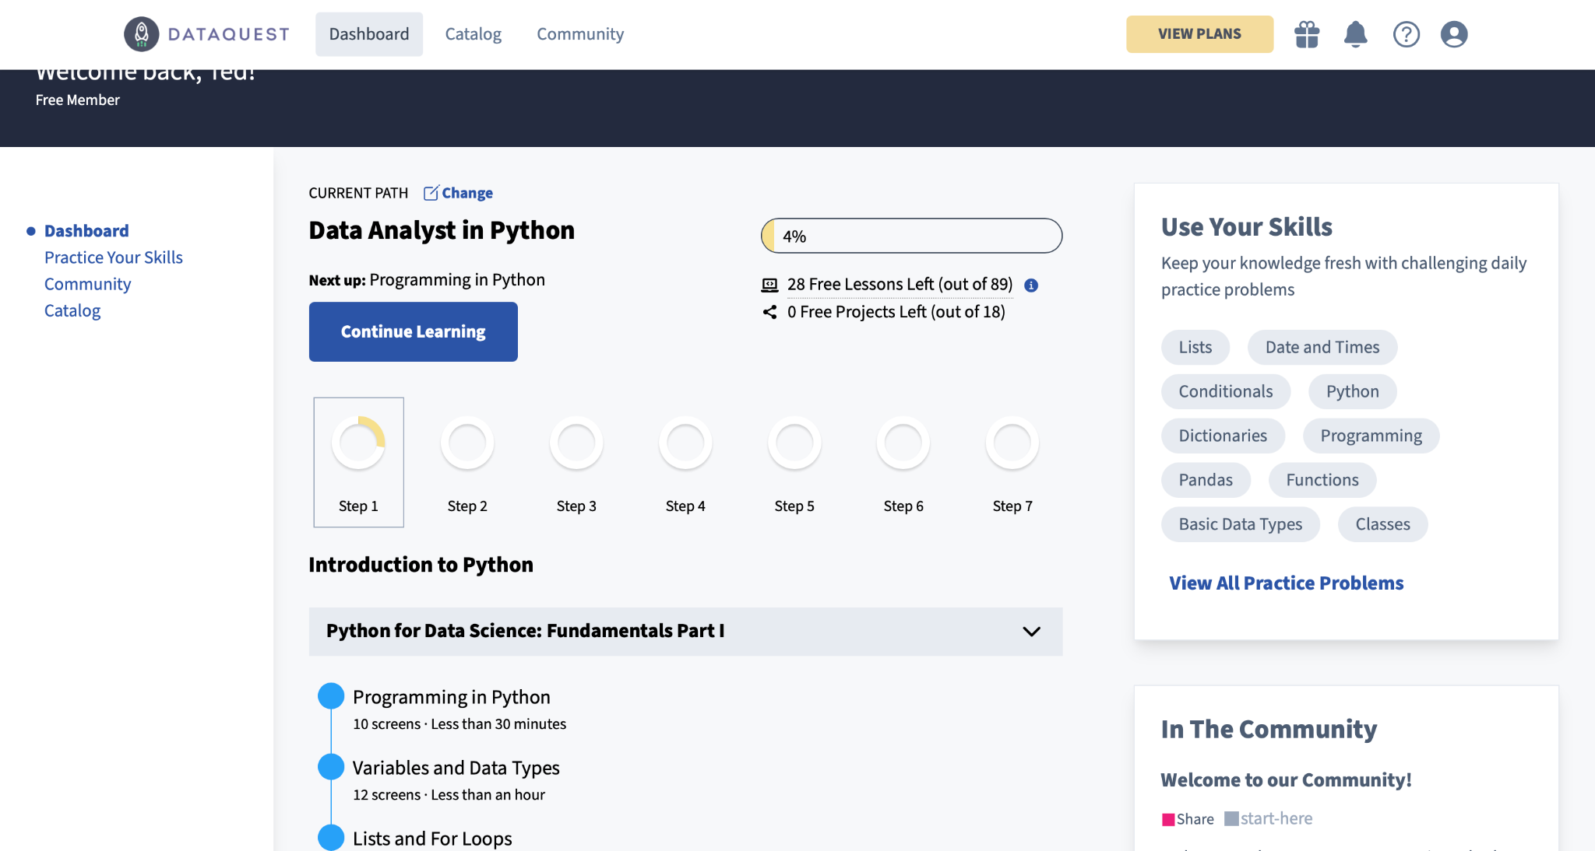

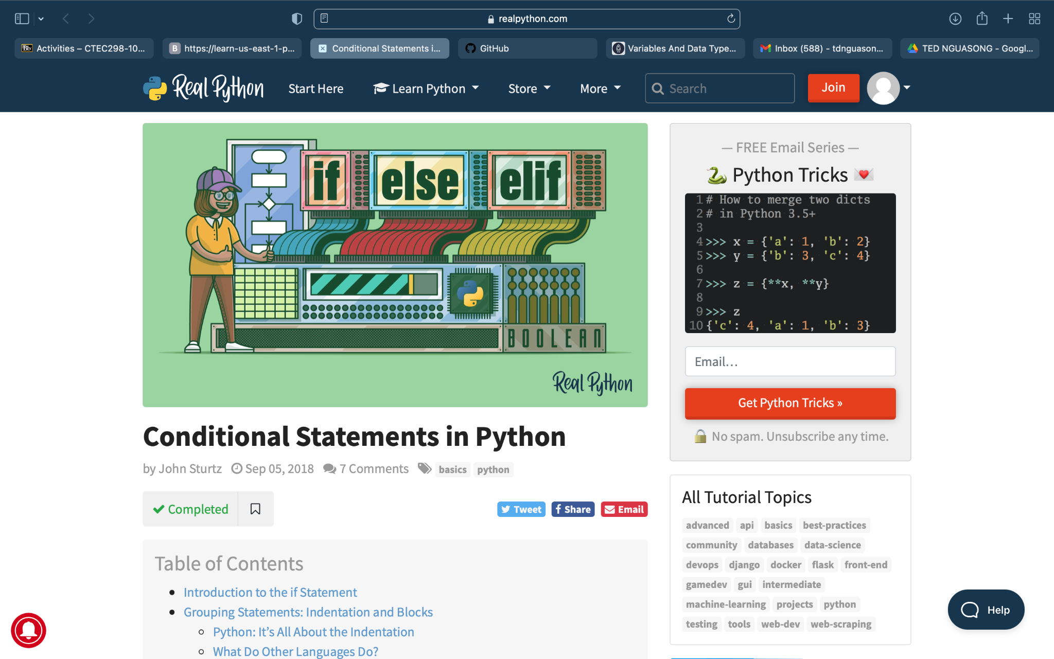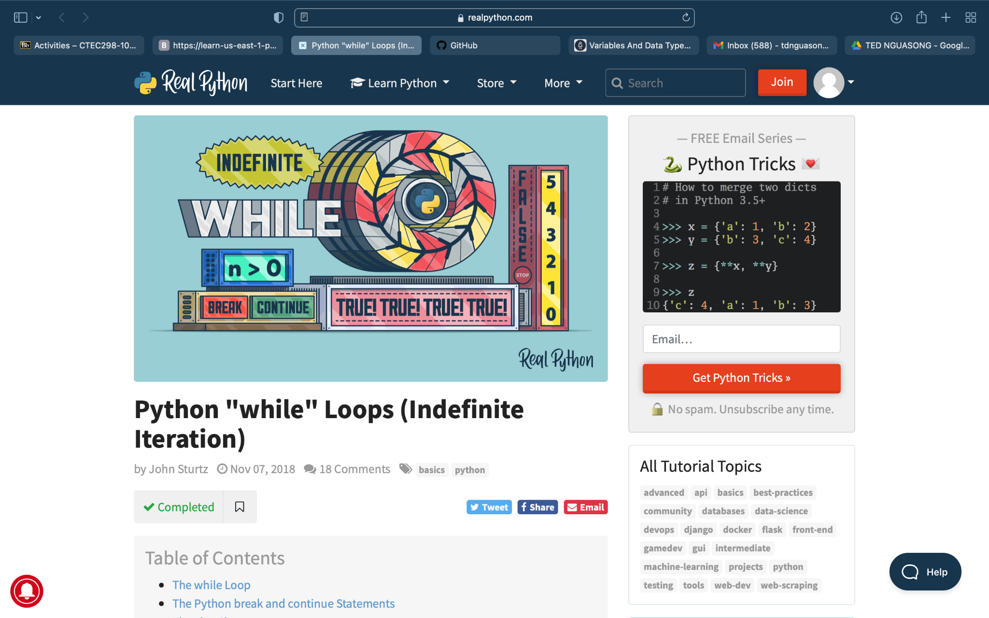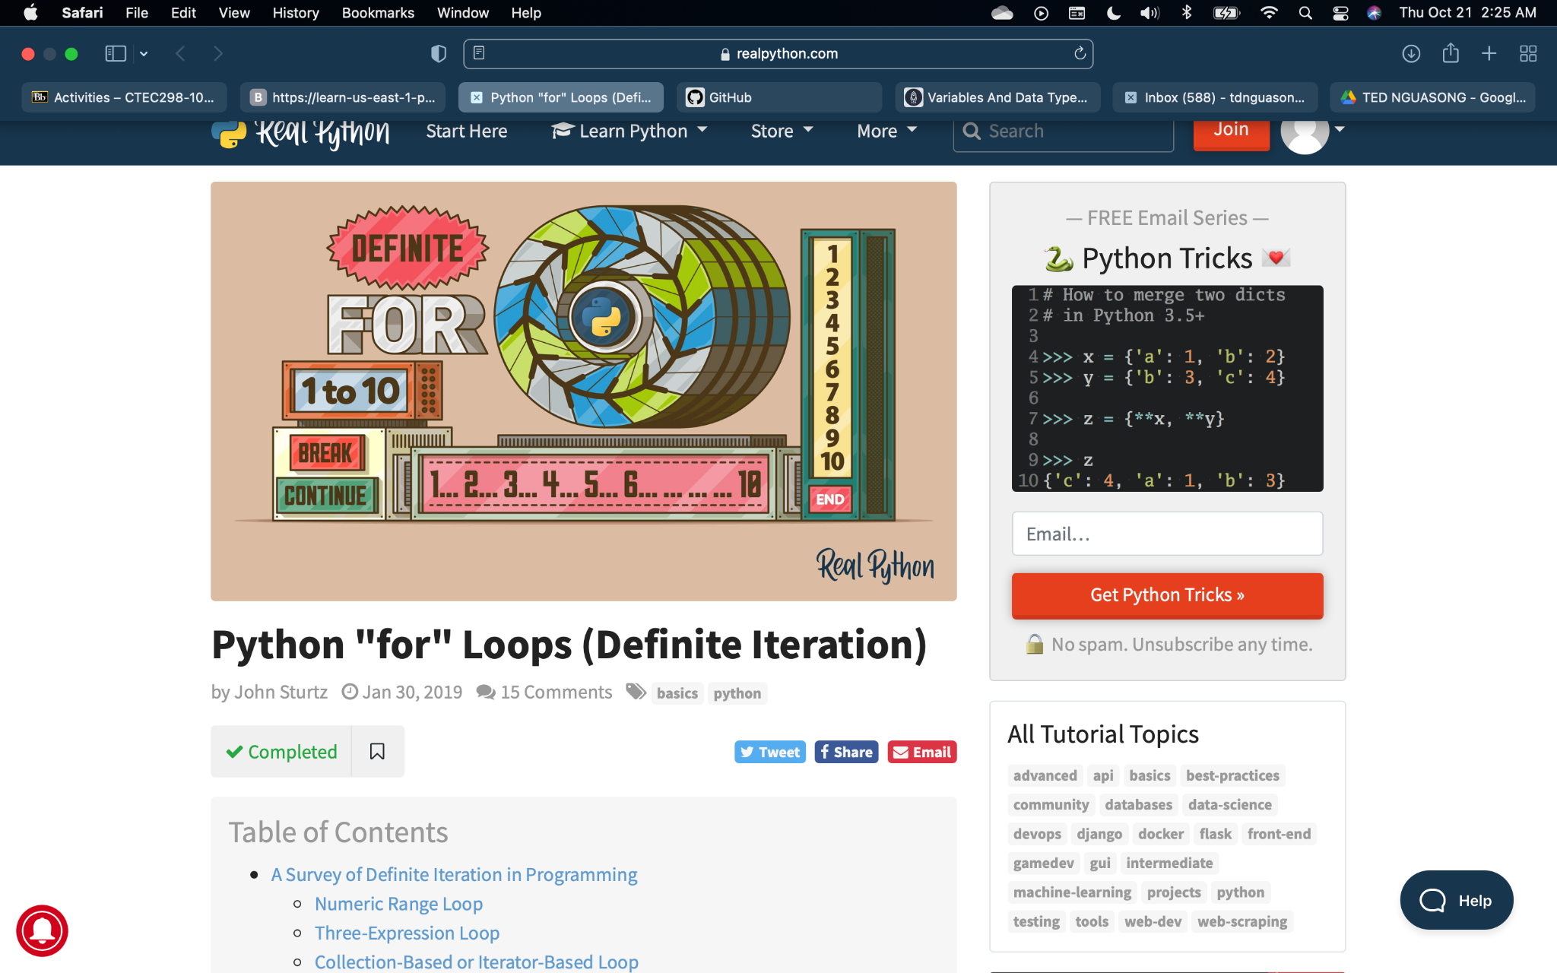

## Tutorials: Jupyter, Matplotlib and Pandas

For the jupyter tutorial

I imported pandas to work with the data given, and Matplotlib to plot charts. That first line isn’t a Python command, but uses something called line magic to instruct Jupyter to capture Matplotlib plots and render them in the cell output. I loaded the data using df = pd.read_csv('fortune500.csv'). I was able to create a histogram out of the data using,

bin_sizes, _, _ = plt.hist(df.year[non_numberic_profits], bins=range(1955,

2006)) From there I formatted the data some more, including the graphs along the way to verify the data.

A bar chart or bar graph is a chart or graph that presents categorical data with rectangular bars with heights or lengths proportional to the values that they represent. The bars can be plotted vertically or horizontally. A bar graph shows comparisons among discrete categories. One axis of the chart shows the specific categories being compared, and the other axis represents a measured value.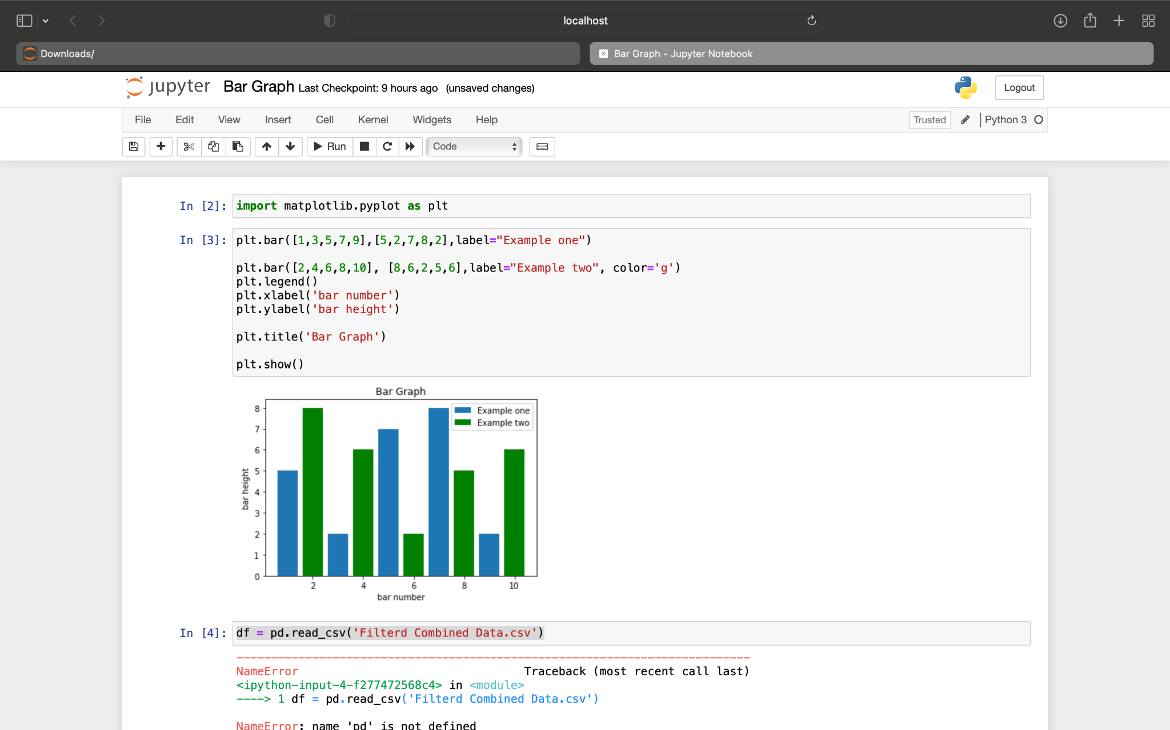

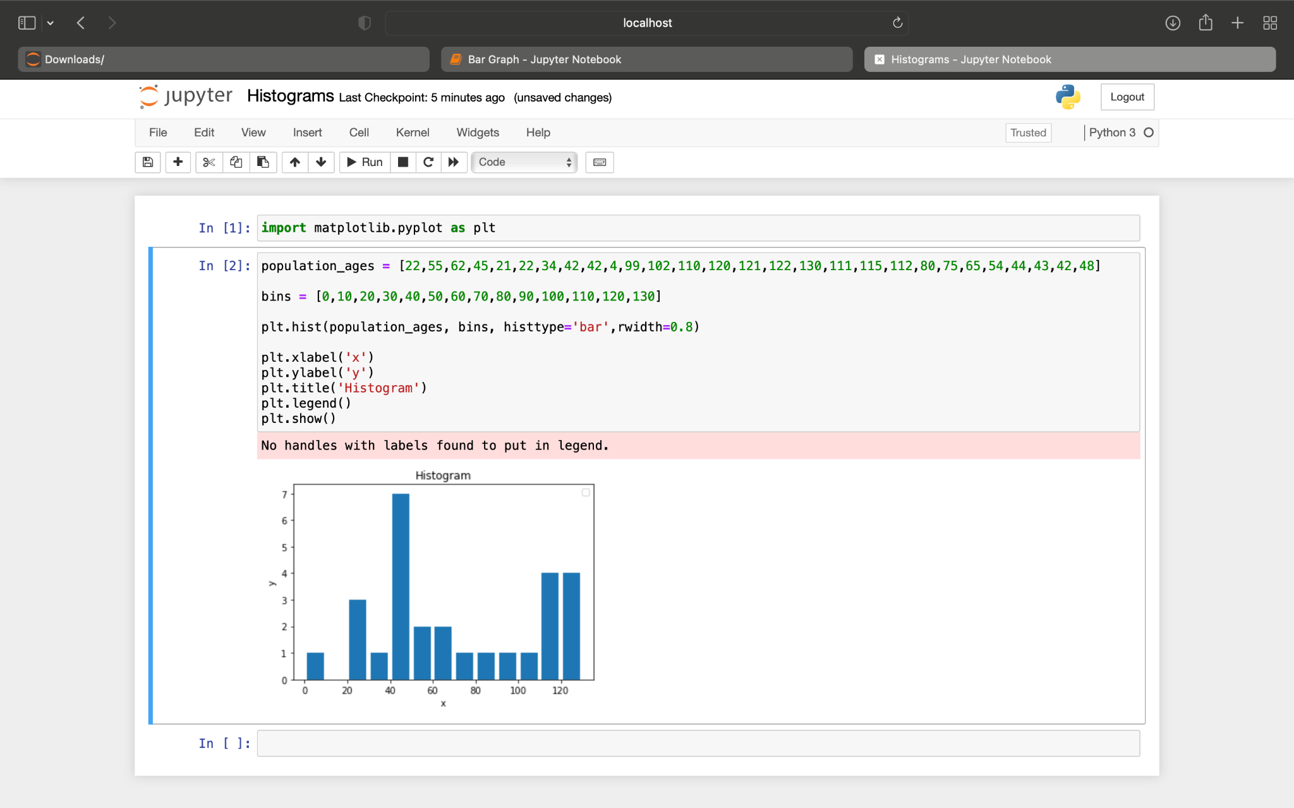

A histogram shows the frequency on the vertical axis and the horizontal axis is another dimension. Usually it has bins, where every bin has a minimum and maximum value. Each bin also has a frequency between x and infinite.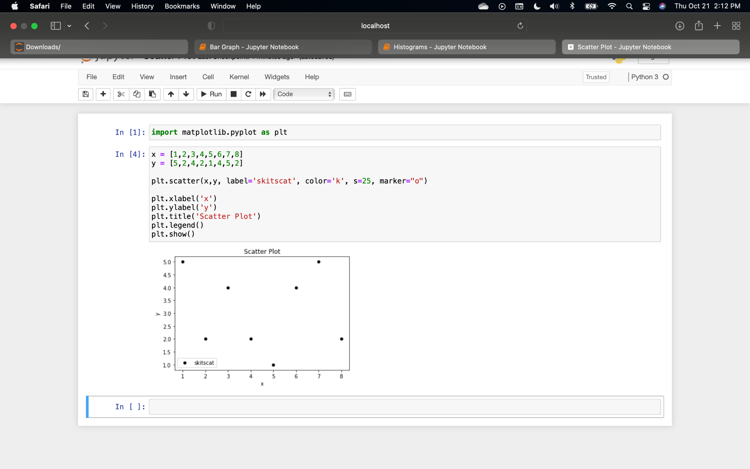

A scatter plot is a type of plot that shows the data as a collection of points. The position of a point depends on its two-dimensional value, where each value is a position on either the horizontal or vertical dimension.

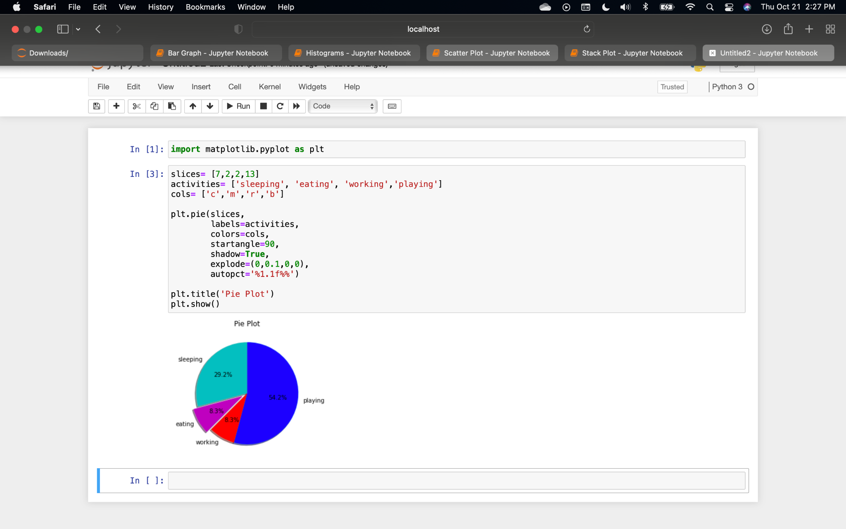

Pie Chart is a circular statistical plot that can display only one series of data. The area of the chart is the total percentage of the given data. The area of slices of the pie represents the percentage of the parts of the data. The slices of pie are called wedges. The area of the wedge is determined by the length of the arc of the wedge. The area of a wedge represents the relative percentage of that part with respect to the whole data.

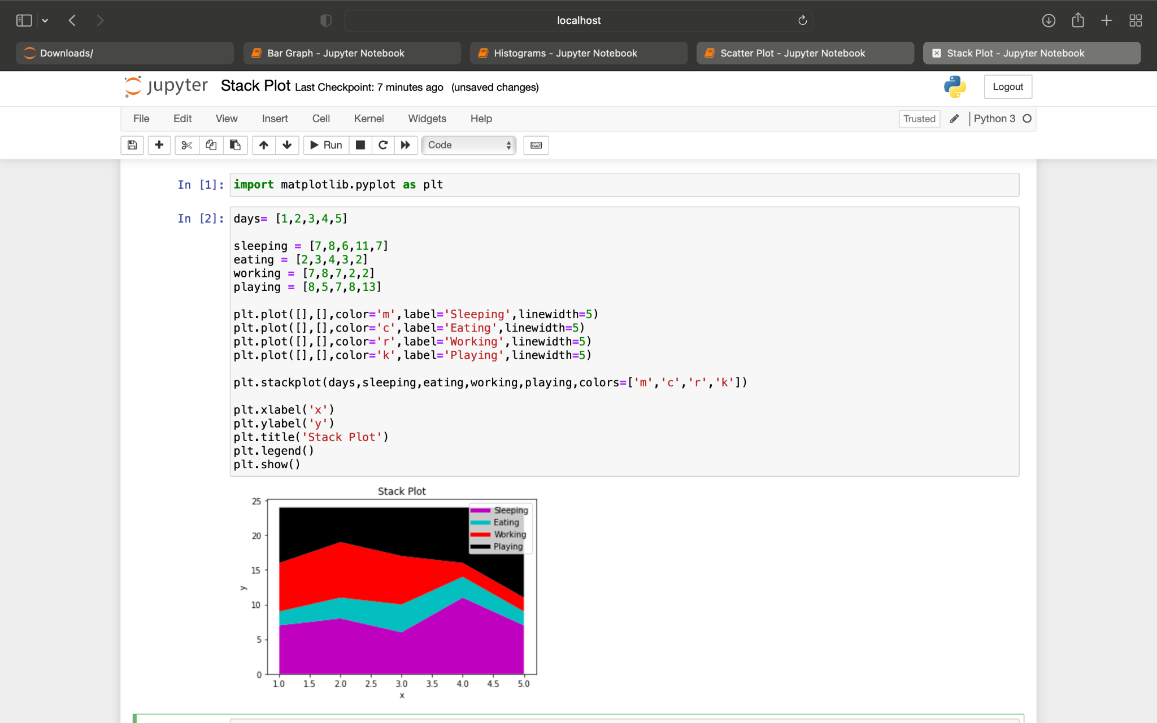

The idea of stack plots is to show “parts to a whole” over time; basically, it’s like a pie-chart, only over time. Stack plots are mainly used to see various trends in variables over a specific period of time.

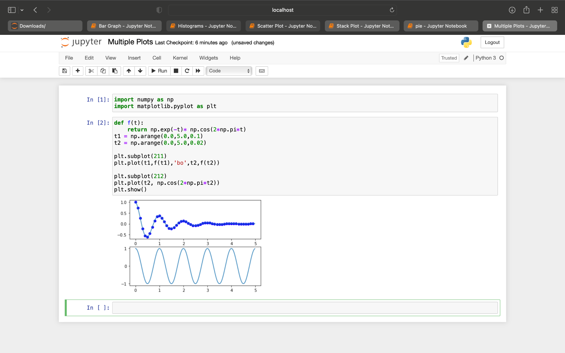

In Matplotlib, we can draw multiple graphs in a single plot in two ways. One is by using subplot() function and other by superimposition of the second graph on the first i.e, all graphs will appear on the same plot.

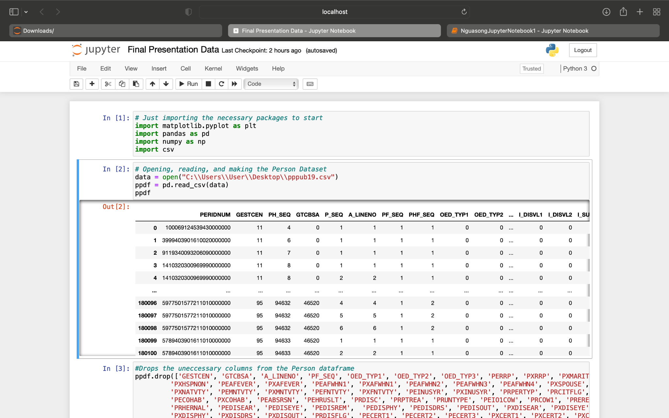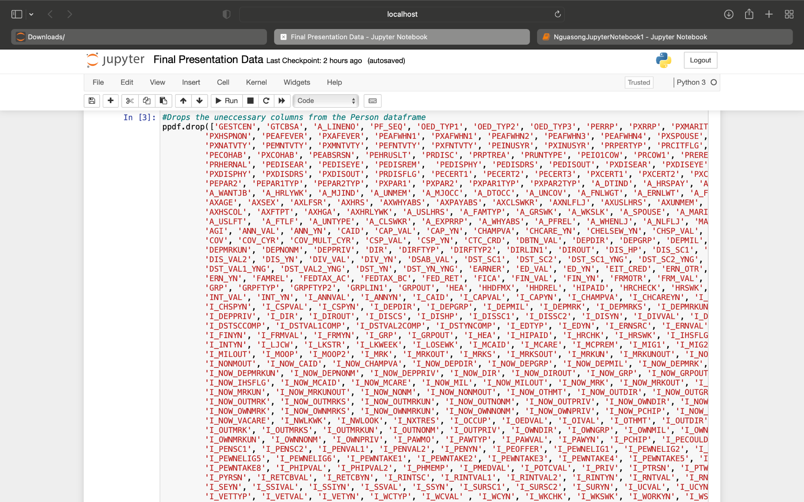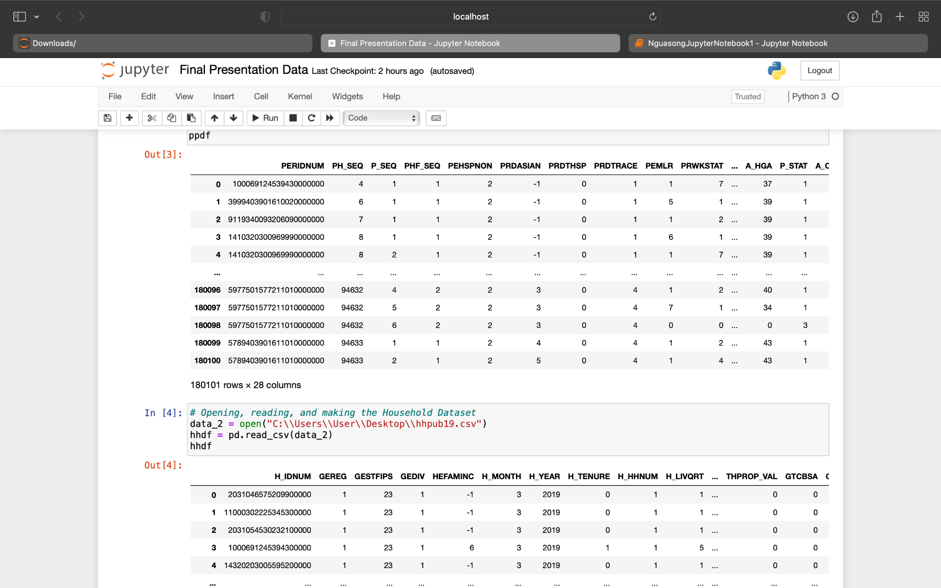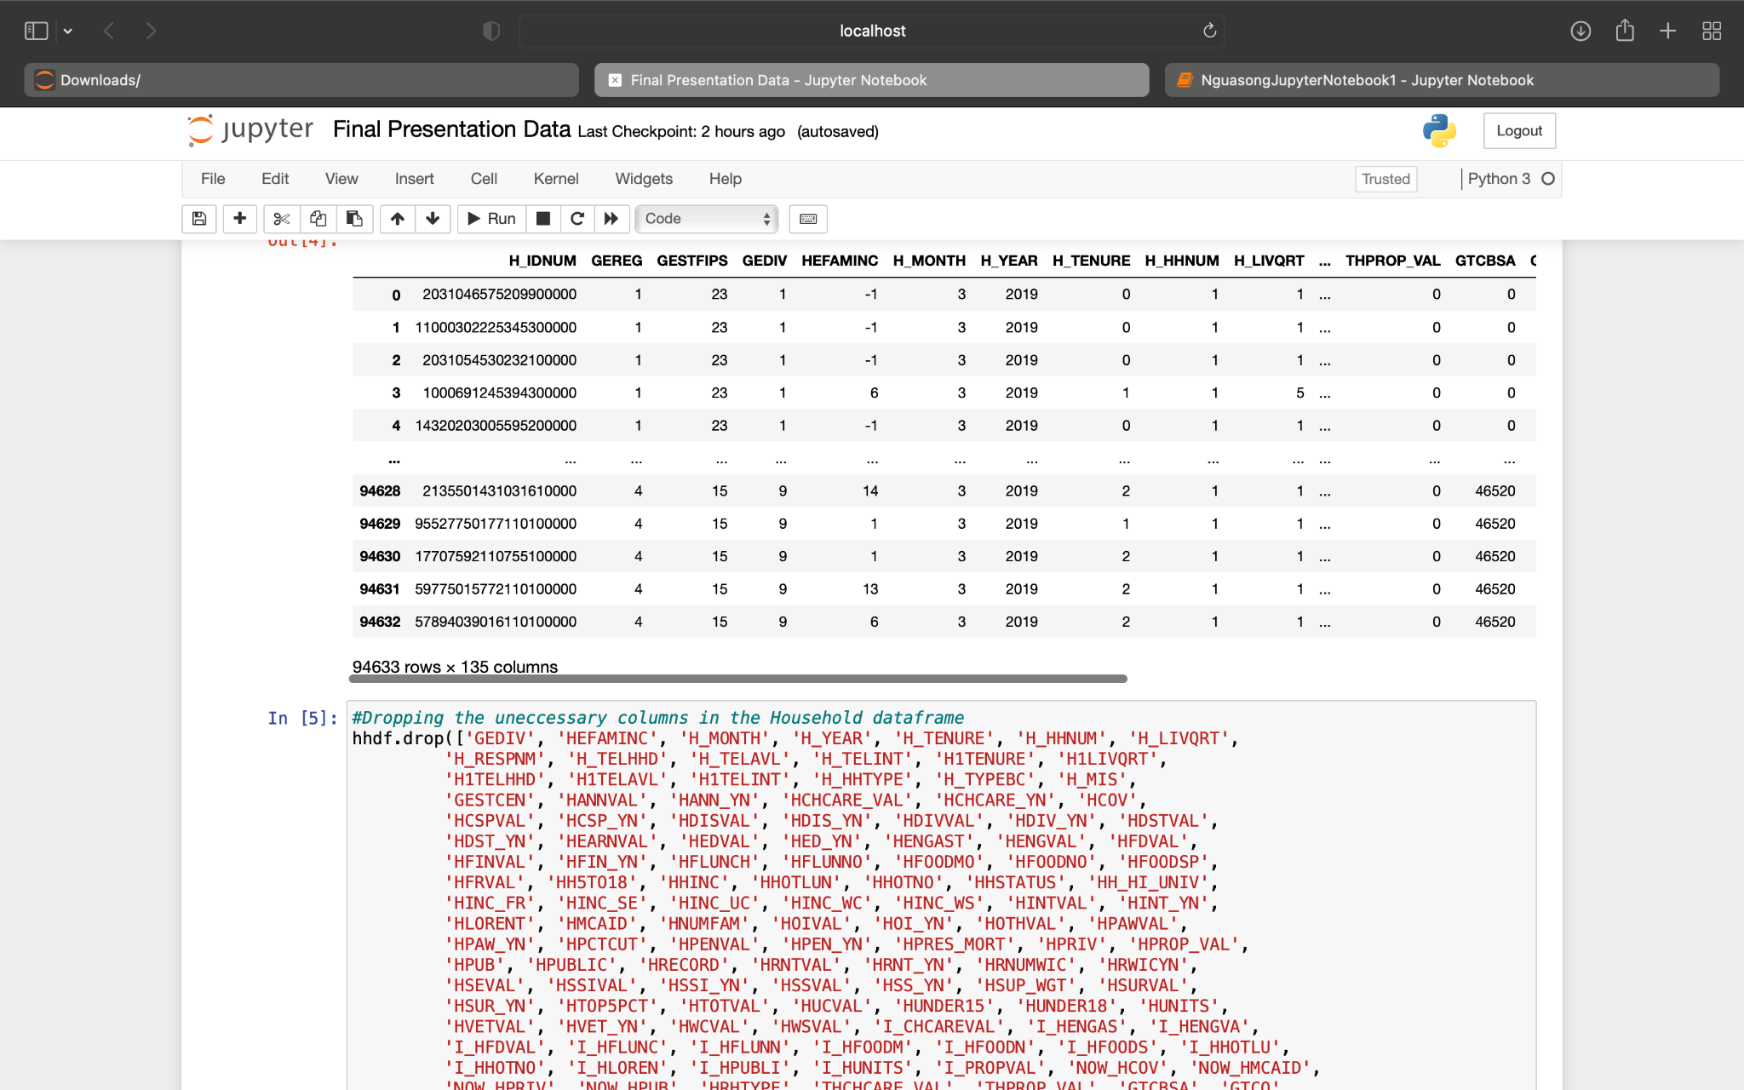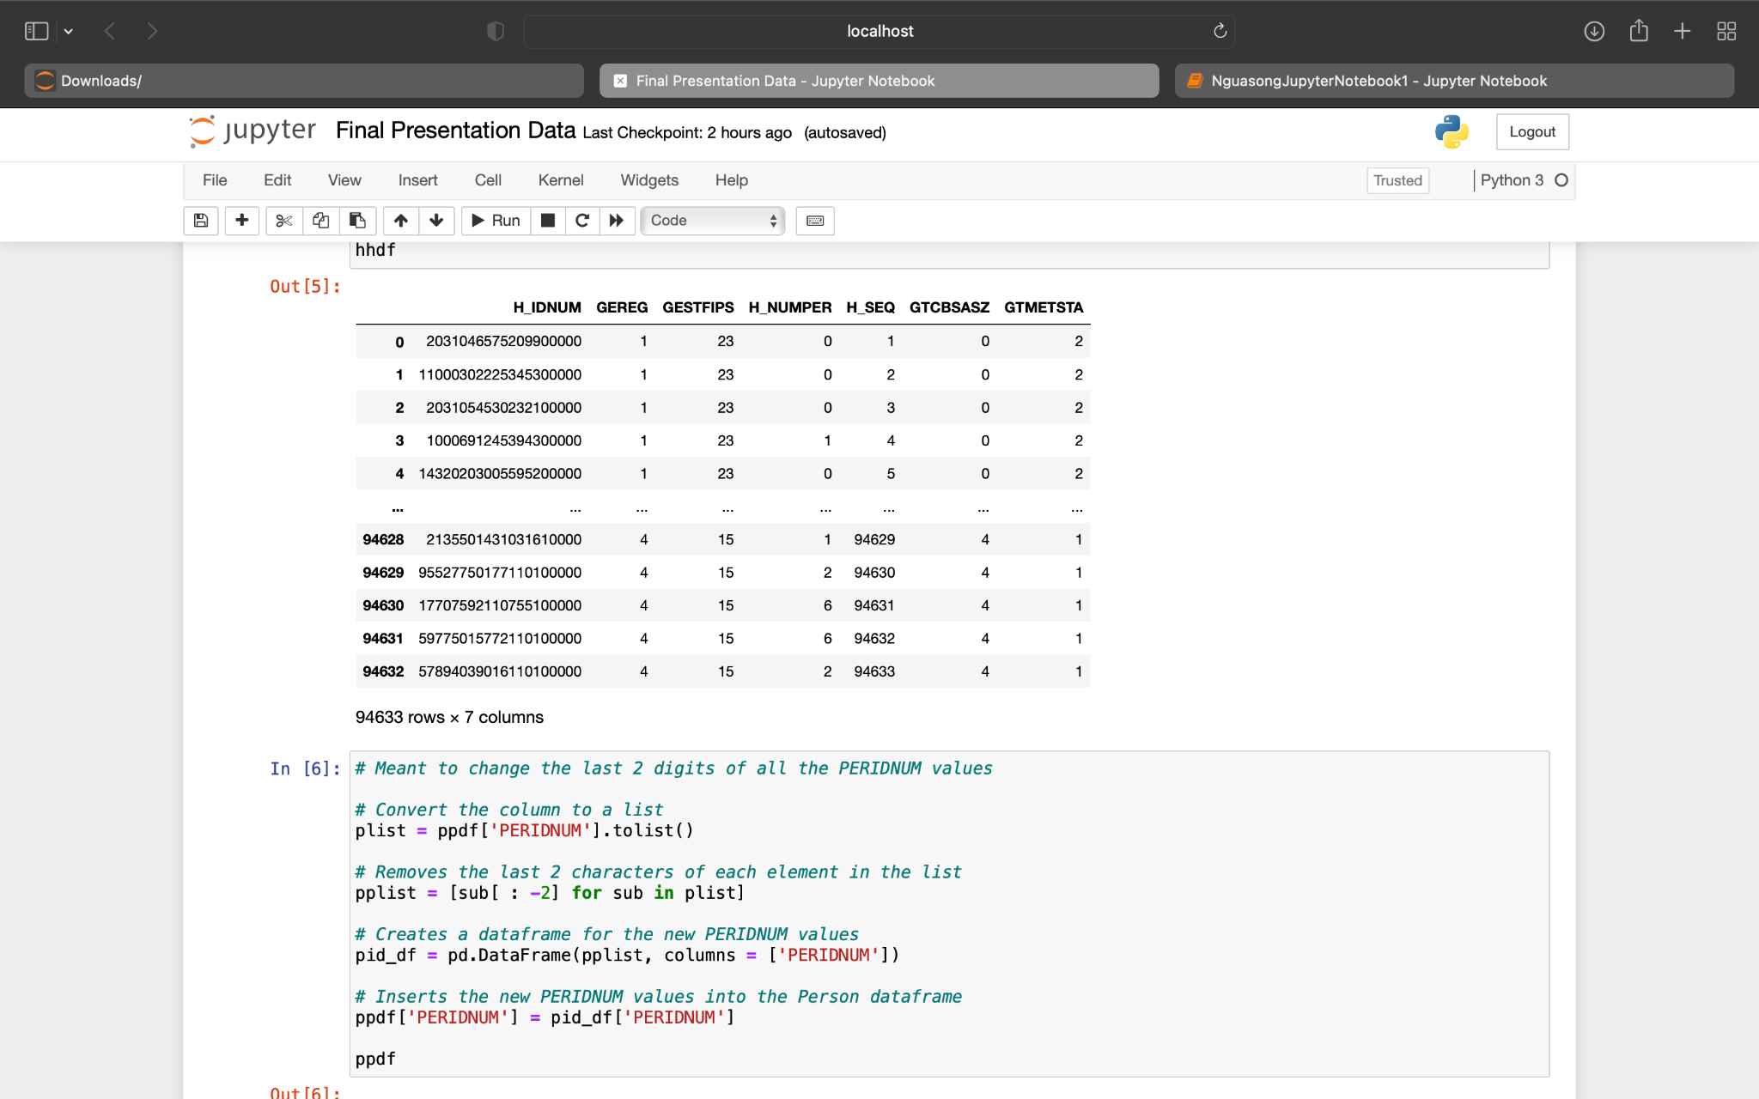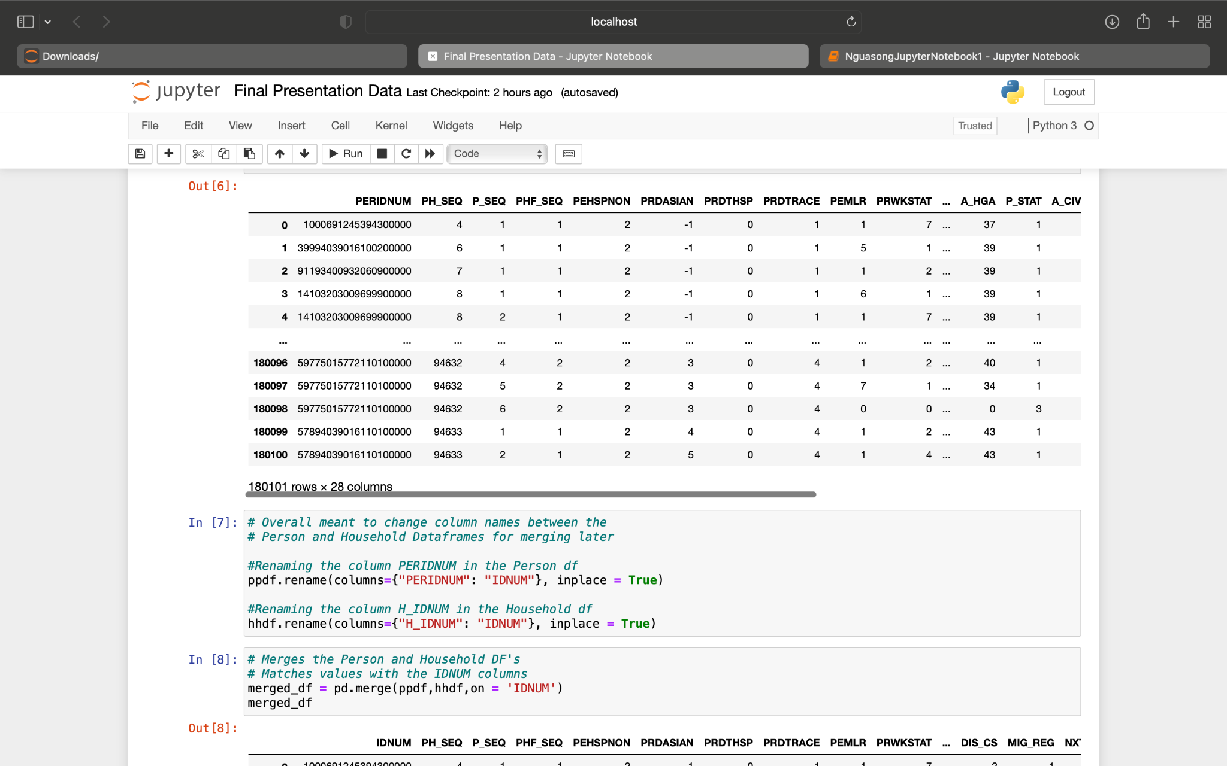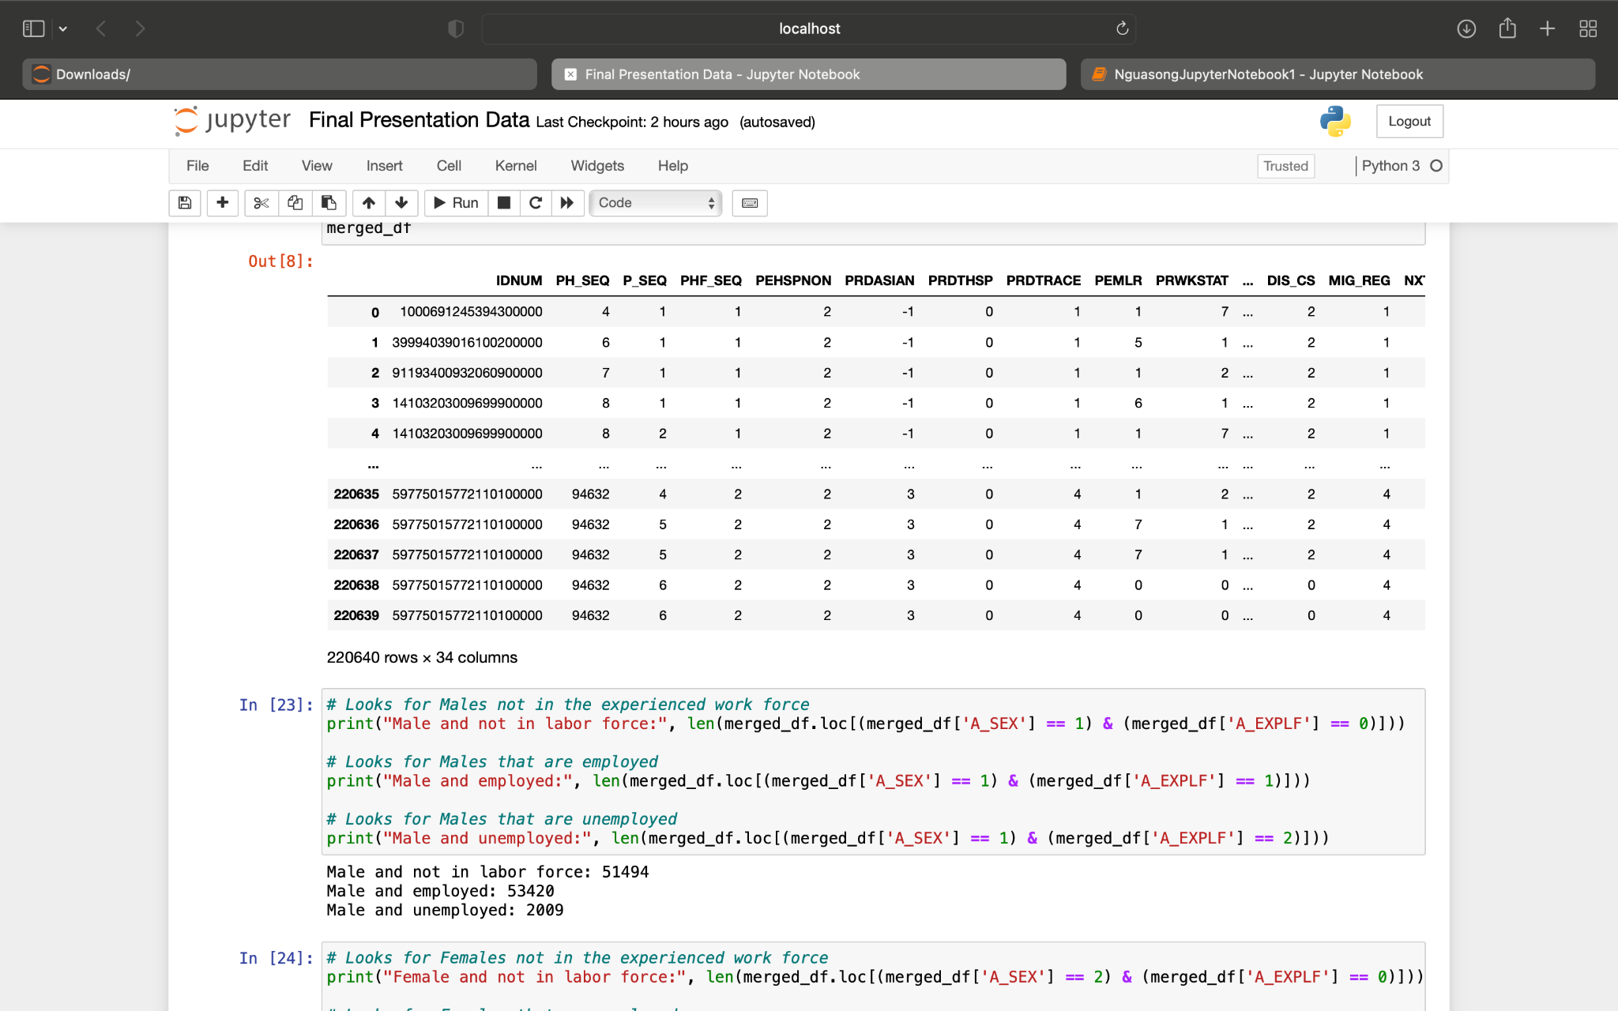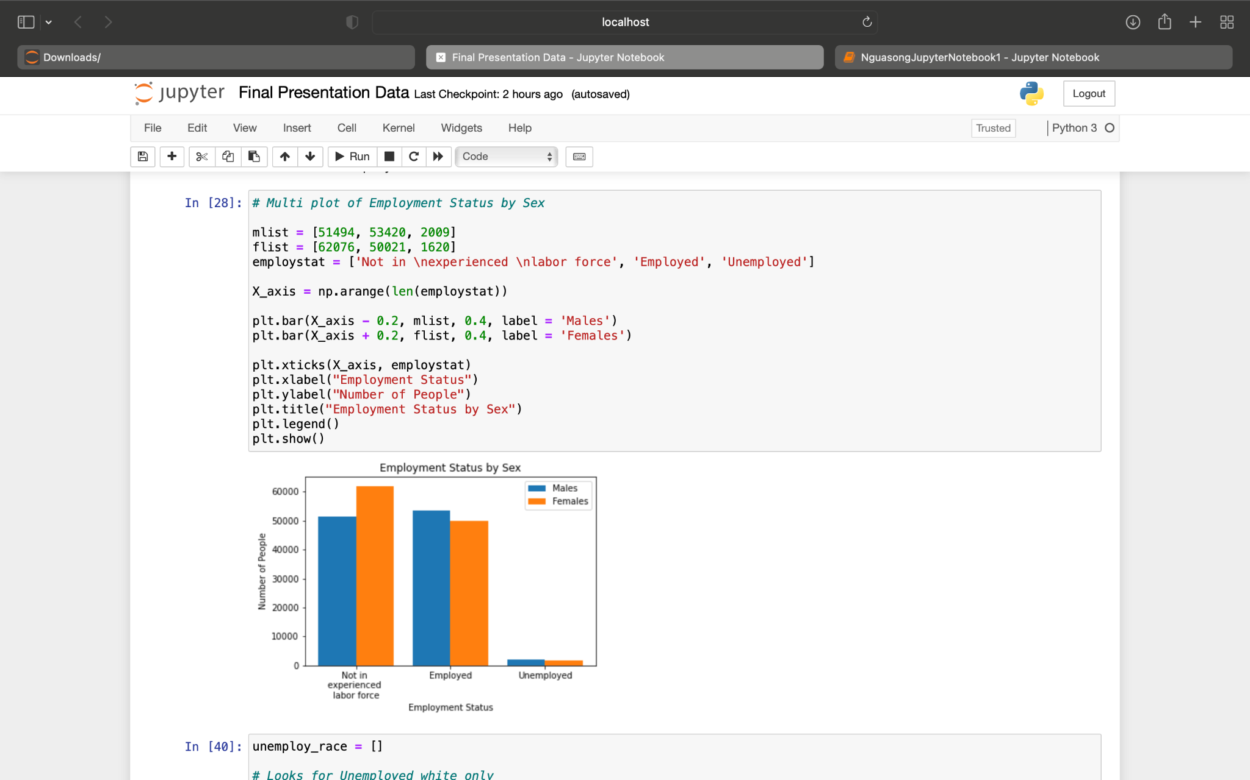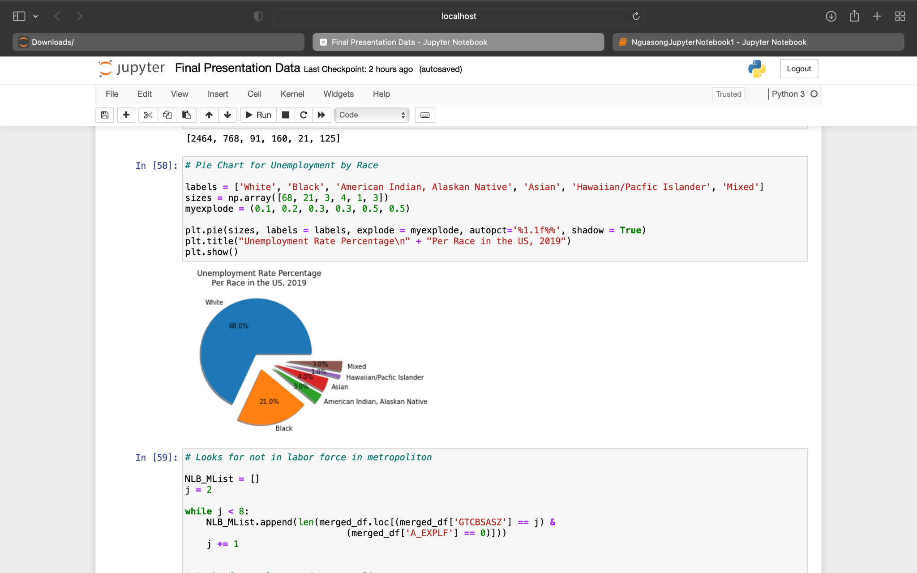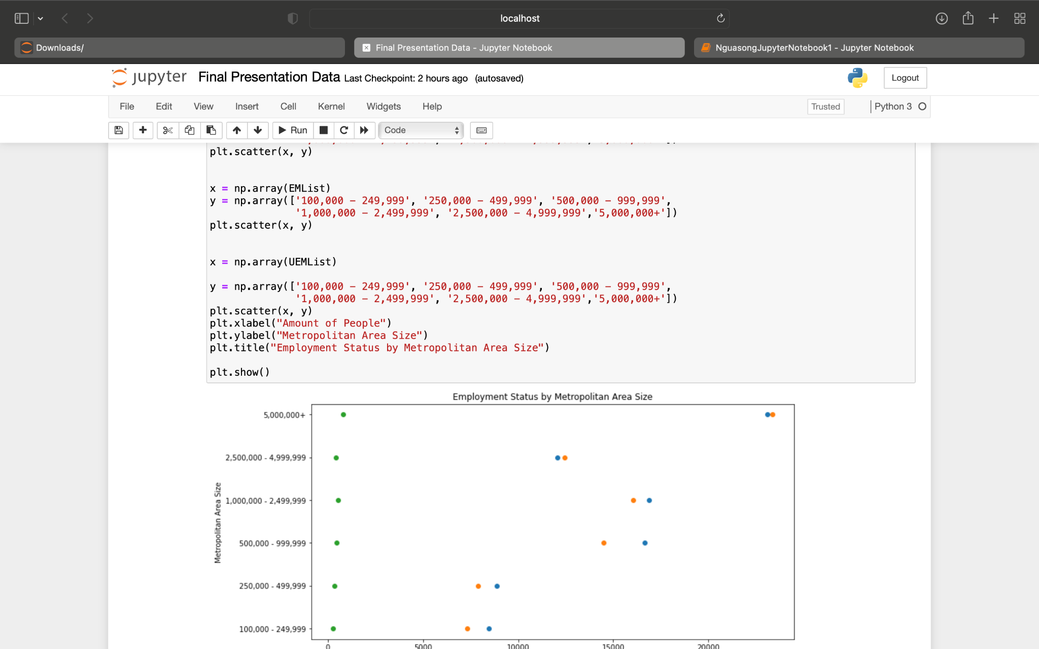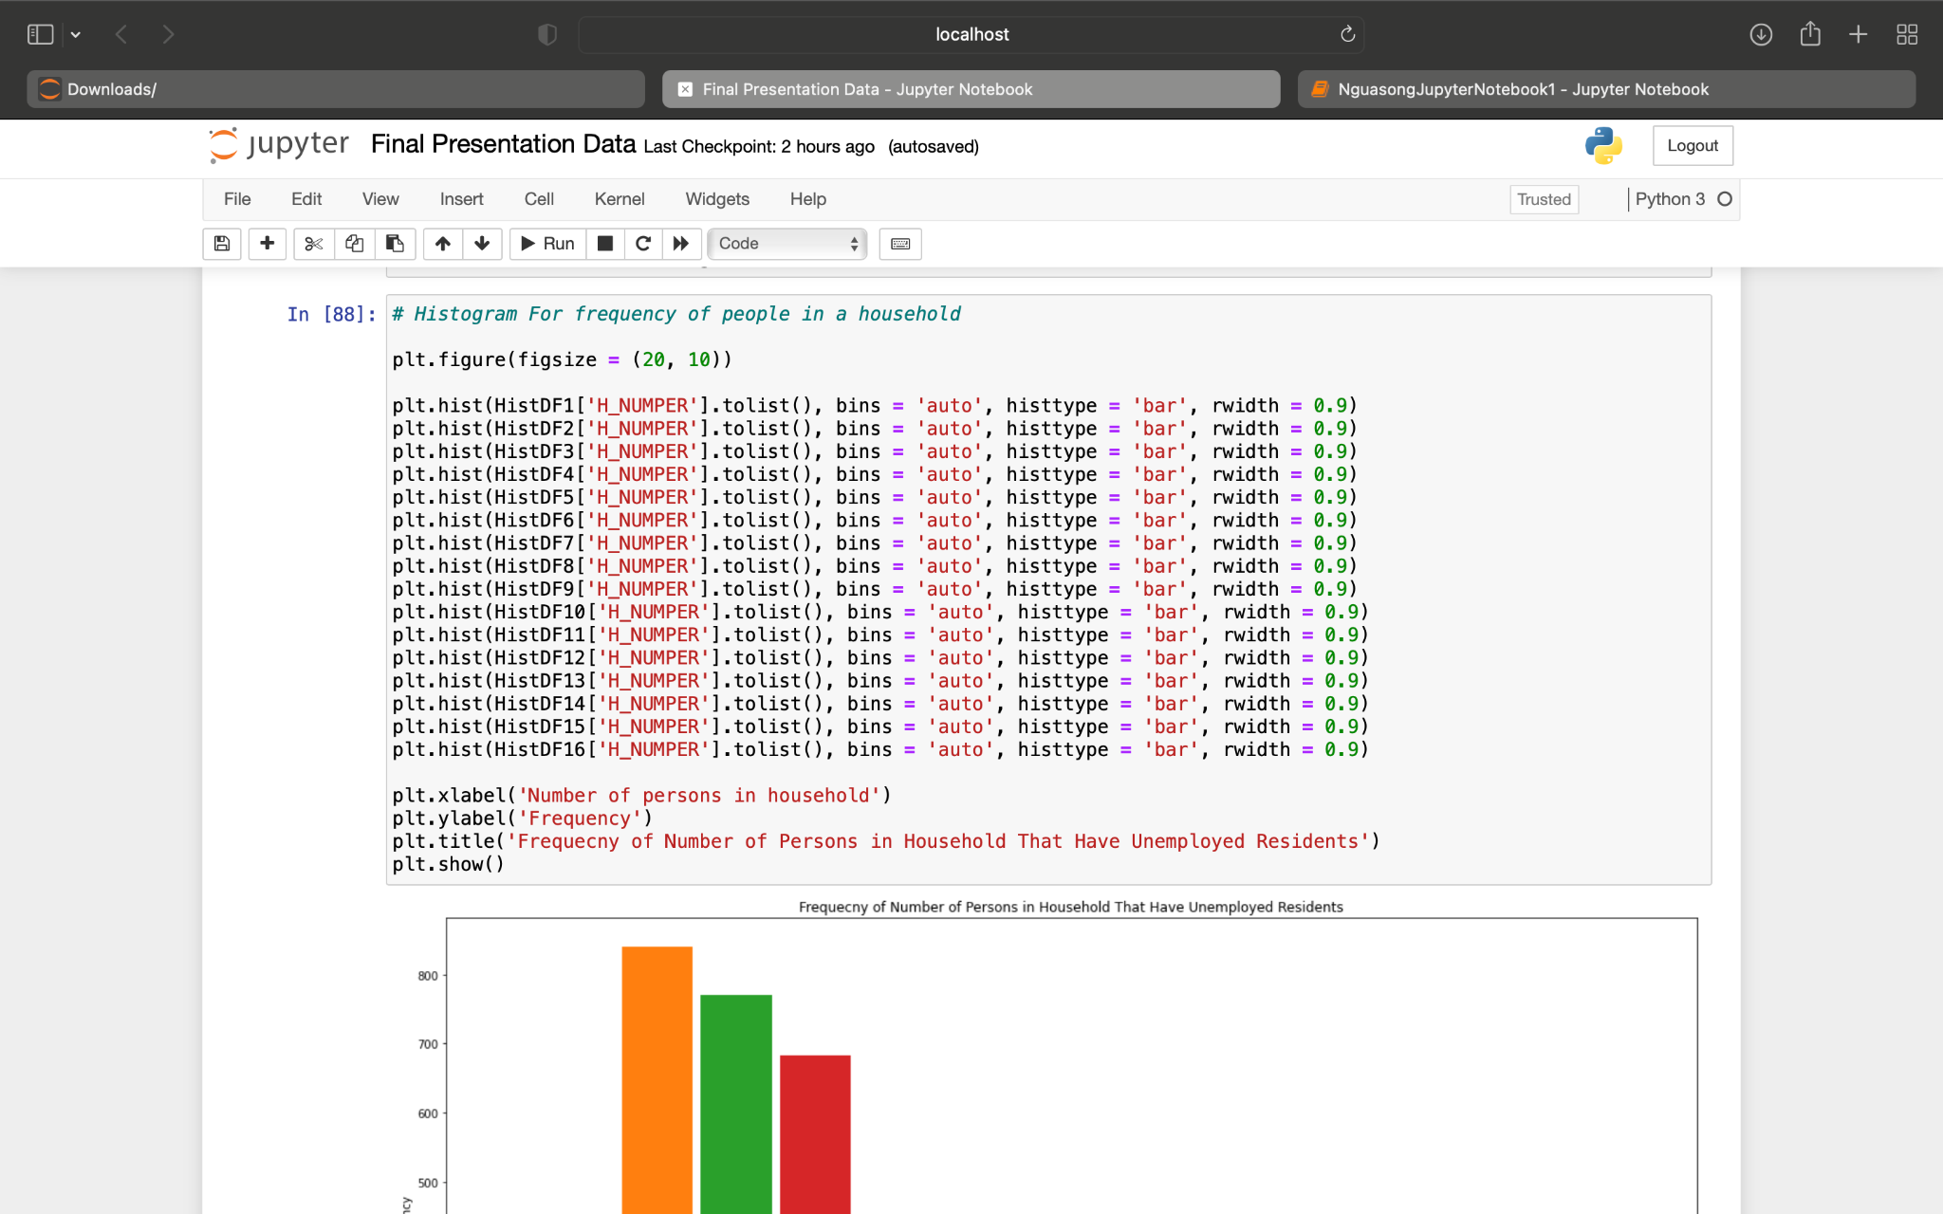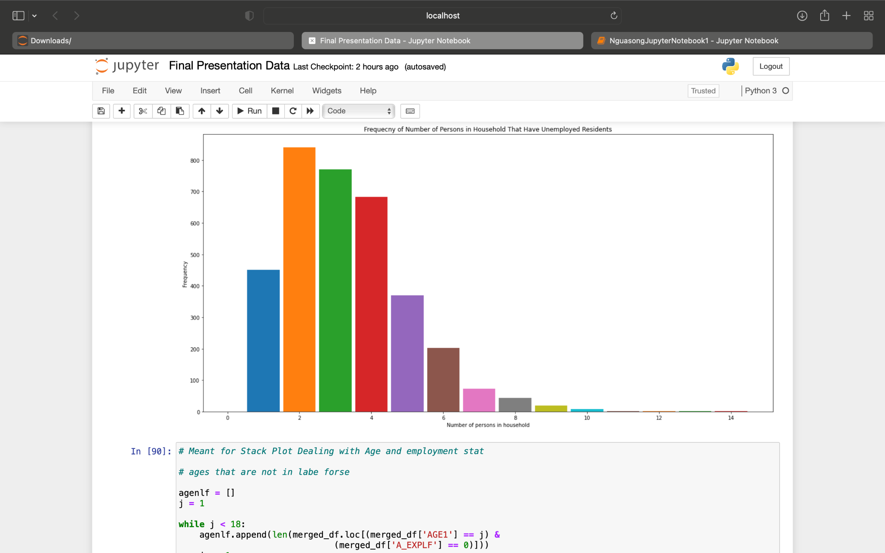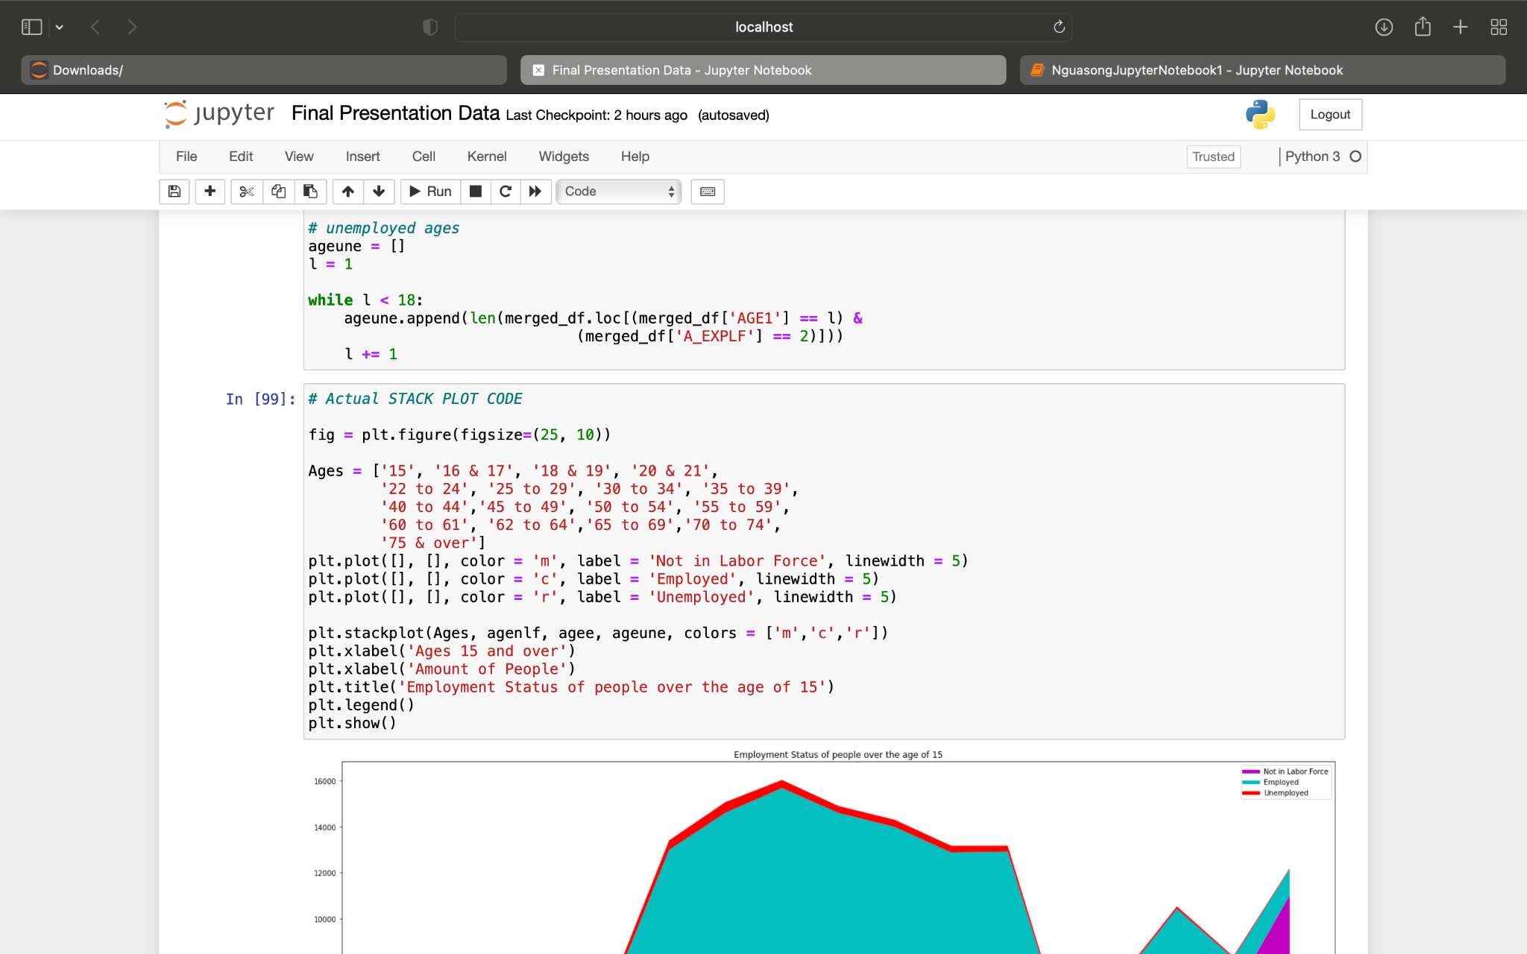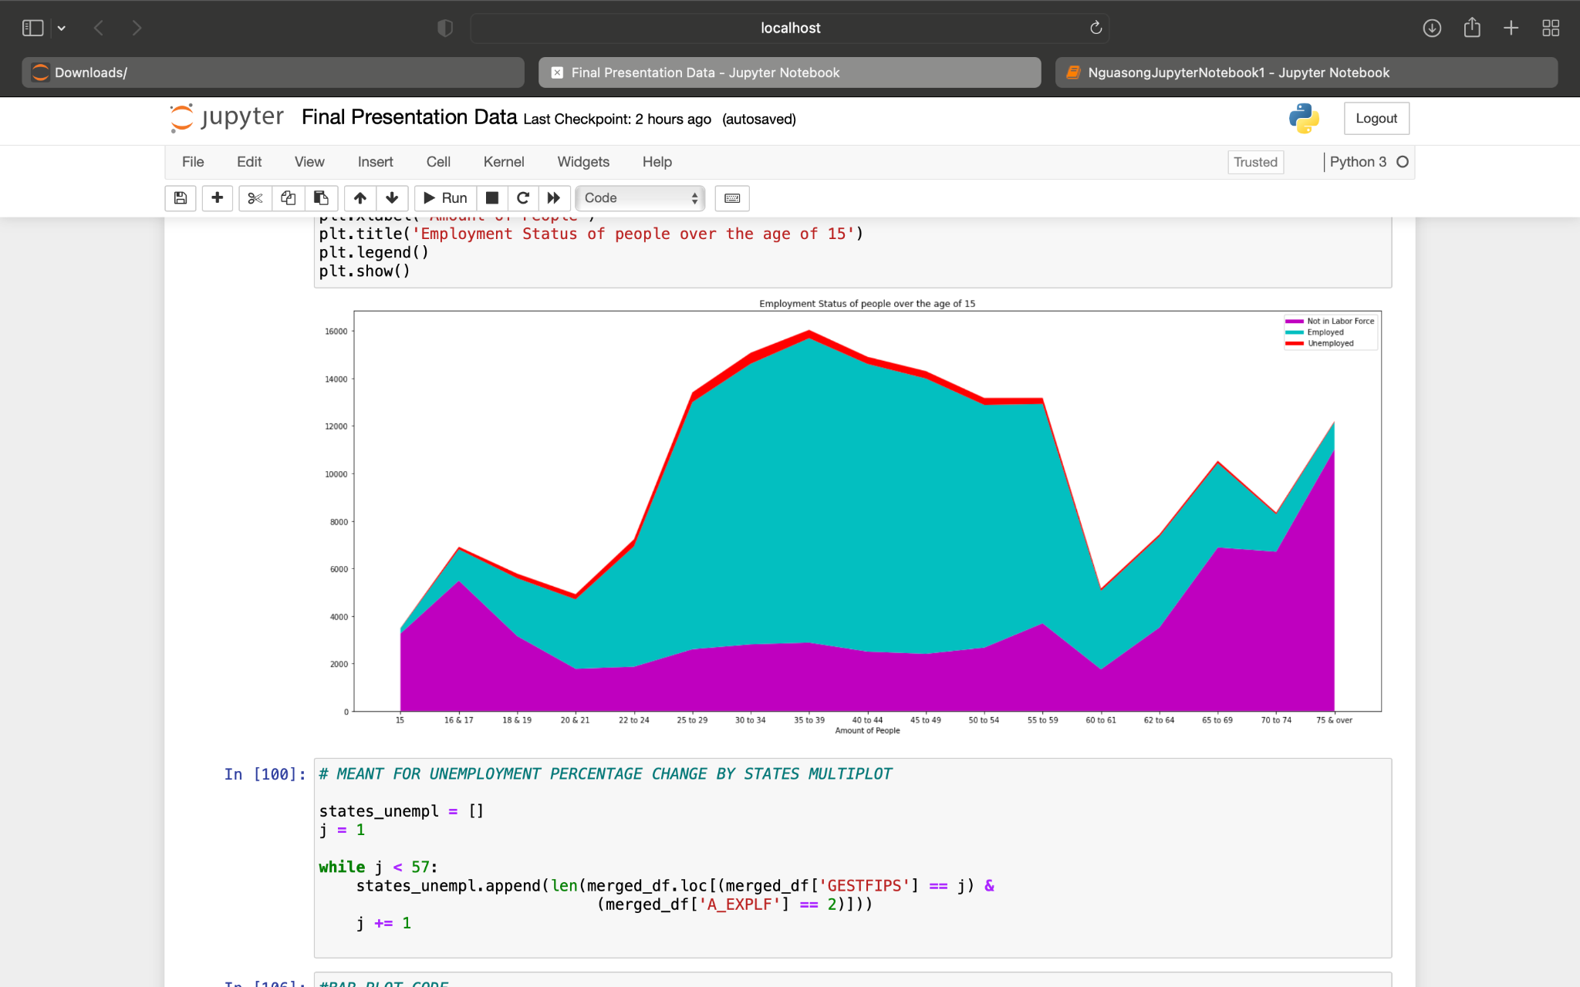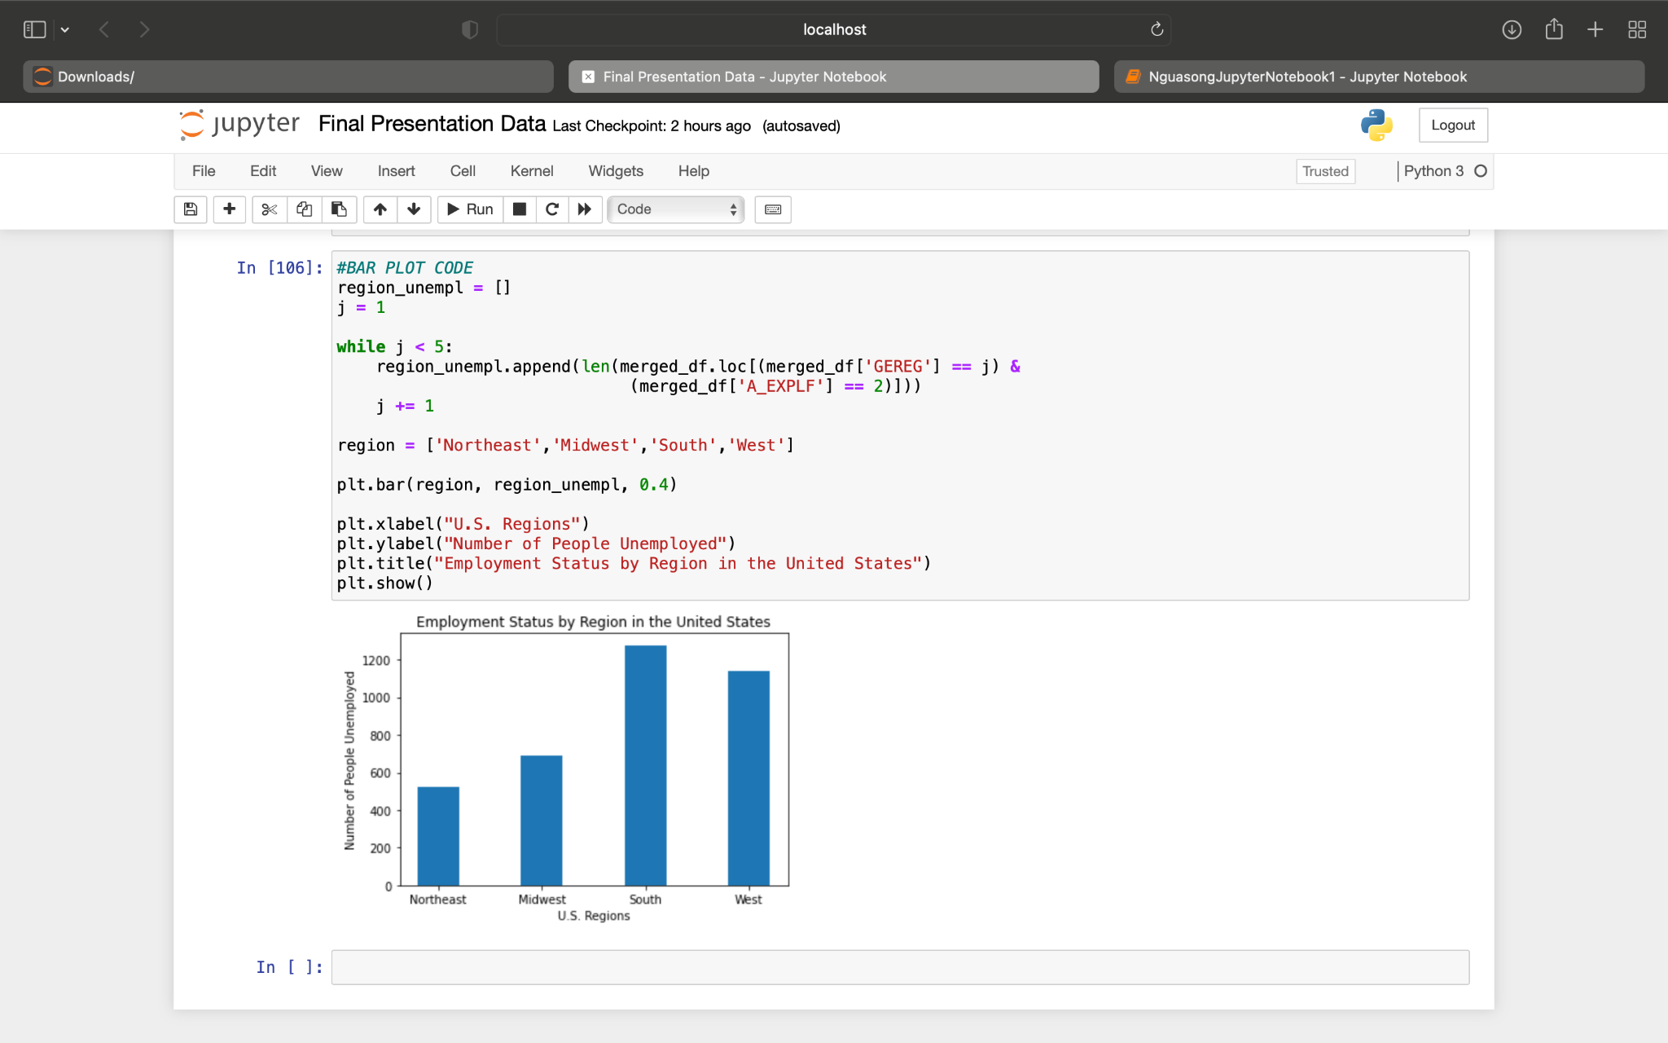

Using my original dataset from CTEC128 project I was able to create various plots and graphs

# Conclusion

I enjoyed the project, being able to use other means of exploring and producing data made me realize I have a lot to learn about databases. While CTEC 128 introduce computing data through application like excel. 298 brought in a different perspective, before having the data cleaned up for you, but now having too wrangled the big data and produce visuals using matplotlib, panda, numpy and jupyter notebook gave me a challenge I was happy too take on that challenge and produce these final visuals.

# References

United States Census Bureau. (2020, April). *Current Population Survey 2019 Annual Social and Economic (ASEC) Supplement*. https://www2.census.gov/programs-surveys/cps/techdocs/cpsmar19.pdf

U.S Bureau of Labor Statistic. (2021, January 22). *Unemployed persons by occupation and sex*. https://www.bls.gov/cps/cpsaat25.htm

U.S. Bureau of Labor Statistics. (n.d.). *Civilian unemployment rate*. Retrieved February 13, 2021, from https://www.bls.gov/charts/employment-situation/civilian-unemployment-rate.htm

U.S. Bureau of Labor Statistics. (2020, May). *Learn more, earn more: Education leads to higher wages, lower unemployment*. https://www.bls.gov/careeroutlook/2020/data-on-display/education-pays.htm

U.S. Bureau of Labor Statistics. (2021, January 27). *Concepts and Definitions (CPS)*. https://www.bls.gov/cps/definitions.htm#unemployed

U.S. Census Bureau. (2019, November 21). *Questionnaires*. The United States Census Bureau. https://www.census.gov/programs-surveys/cps/technical-documentation/questionnaires.html

U.S. Department of Agriculture Economic Research Service. (2019, September 23). *Rural Employment and Unemployment*. https://www.ers.usda.gov/topics/rural-economy-population/employment-education/rural-employment-and-unemployment/#lfp